COVER LETTER

To
The Editor in Chief
Journal of Global Pharma Technology,

Respected Sir/Madam

I am submitting a clinical case report with title “Empagliflozin managed Type 2 Diabetes Mellitus in Insulin induced Hypertension: A case report” for possible publication in Journal of Global Pharma Technology, so, we found this journal is an appropriate for communicating the article to all healthcare professionals. The authors declare that the manuscript is original, not published before, and not being considered for publication elsewhere. All authors have reviewed and accepted to submit this report to this journal

In addition, the authors declare that there are no financial issues, Conflicts of interests, related this research and we have not received any funding for doing this work from any government, non-government, and any other means of sources. The number of words in the abstract are 108 and the number of words in the manuscript are 1182.

Looking forward

Corresponding Author
Dr. Swathi Swaroopa Borra
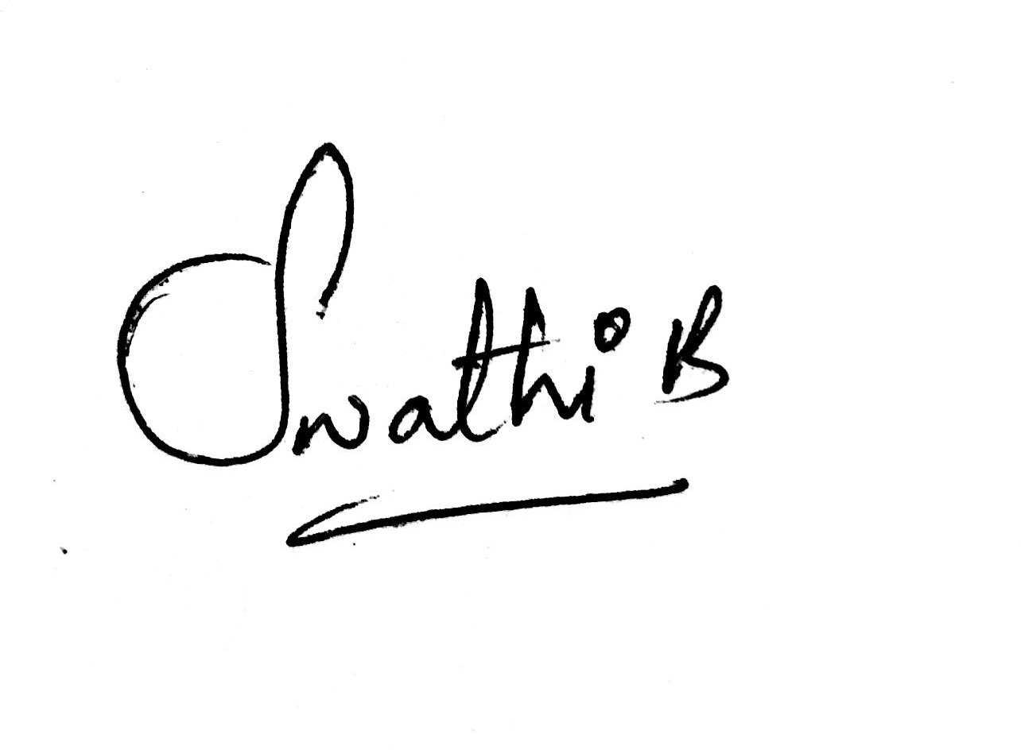
Contact Number: +919629547089
Mail ID: swathimasthani@hotmail.com

CHECKLIST
- Manuscript title: Empagliflozin managed Type 2 Diabetes Mellitus in Insulin induced Hypertension: A case report
- Category (e.g. original article, review, short report, etc.): Clinical Case Report
- Total number of manuscript pages: 06
- Number of tables: 03
- Number of figures: 0
- Special requests: Nil
- Suggested reviewers (names and e-mail, postal addresses)
Indian | Foreign
1. Dr. K P ARUN  kparun@jssuni.edu.in  JSS College of Pharmacy,  Ooty, Tamilnadu. Pin: 643001  ___________________ | 1. __NIL_________________  ___________________  ___________________
2. Mr.M Venkata Subbaiah  pharmachinna@gmail.com  Ramireddy College of Pharmacy,  Kadapa, Andhra Pradesh  ___________________ | 2 ___________________  ___________________
3. ___________________  ___________________  ___________________ | 3. ___________________  ___________________  ___________________
- Authors’ declaration: Included
- Corresponding author’s name, current postal and e-mail addresses, and telephone and fax number:
Corresponding Author:

Dr. Swathi Swaroopa Borra, Pharm D,
Lecturer,
Department of Pharmacy Practice
JSS College of Pharmacy, JSS Academy of Higher
Education & Research
Ooty, Tamil Nadu, 643001, India
E-mail: swathimasthani@hotmail.com
Tel: +919629547089.

AUTHOR’S DECLARATION
We, the authors of the manuscript titled ‘Empagliflozin managed Type 2 Diabetes Mellitus in Insulin induced Hypertension: A case report’, hereby submit it for consideration for publication as a Clinical Case Report (category) in Journal of Global Pharma Technology,.
We agree to the following:
- This manuscript is our original work and is free from plagiarism.
- This manuscript or a substantial part of it has not been submitted to any other journal for publication. It has also not been published previously.
- The data in this study have not been used for any other manuscript published by us.
- Each of us individually takes full responsibility for the design and conduct of the study, had full access to the data and controlled the decision to publish the study.
- We agree to the order of authorship as stated on the title page of the manuscript.
- Each of us has seen the final version of the manuscript submitted for publication and has approved of it.
- All conflicts of interest are stated in writing.
- In the event of publication of this manuscript by Journal of Global Pharma Technology, the copyright to this work shall stand transferred to the Journal.

 | Author Name | Signature
 | Raja. A__________________ | 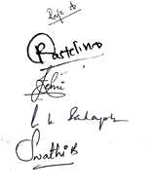  _________________________
 | Renita Castelino___________ | _________________________
 | Jemi Rachel Shaji__________ | _________________________
 | Sadagoban G K____________ | _________________________
Corresponding Author | Swathi Swaroopa Borra_____ | _________________________

TITLE PAGE
Clinical Case Report
Empagliflozin managed Type 2 Diabetes Mellitus in Insulin induced Hypertension: A case report
Raja. A¹; Sadagoban G K²; Jemi Rachel Shaji³; Renita Castelino³; Swathi Swaroopa Borra^{2*}
¹MD, Department of General medicine, Government Medical College Hospital, Ooty, Tamilnadu, India.
² Lecturer, JSS College of Pharmacy, JSS Academy of Higher Education & Research, Ooty, Nilgiris, Tamil Nadu, India
³ Pharm D Intern, JSS College of Pharmacy, JSS Academy of Higher Education & Research, Ooty, Nilgiris, Tamil Nadu, India.

Short Title: Role of Empagliflozin in Insulin induced hypertension
*Corresponding Author:
Dr. Swathi Swaroopa Borra, Pharm D,
Lecturer,
Department of Pharmacy Practice
JSS College of Pharmacy, JSS Academy of Higher
Education & Research
Ooty, Tamil Nadu, 643001, India
Tel: +919629547089
E-mail: swathimasthani@hotmail.com

First Author

1. RAJA. A, M.D
Department of General Medicine,
Government Medical College Hospital,
Ooty, Tamilnadu, India-643001
Email id: drrajacpm@gmail.com
Phone no. +916385253324

Co-Authors
2. G.K SADAGOBAN, PharmD
Department of Pharmacy Practice,
JSS College of Pharmacy, JSS Academy of Higher Education & Research
Ooty, Tamilnadu, India-643001
Email id: sadagoban@jssuni.edu.in
Phone no. +919894876656
3. JEMI RACHEL SHAJI, PharmD
Department of Pharmacy Practice,
JSS College of Pharmacy, JSS Academy of Higher Education & Research
Ooty, Tamilnadu, India-643001
Email id: jemirachel1996@gmail.com
Phone no. +919751003715

4. RENITA CASTELINO, PharmD
Department of Pharmacy Practice,
JSS College of Pharmacy, JSS Academy of Higher Education & Research
Ooty, Tamilnadu, India-643001
Email id: renino16@gmail.com
Phone no.+919619488196

Number of Tables: 3
Number of Figures: Nil
Abstract Word Count: 108
Main Body Word count: 1182
Keywords: Insulin-induced hypertension, Empagliflozin, Type 2 diabetes mellitus, obesity, case report.

